**GANPAT UNIVERSITY**

**U. V. PATEL COLLEGE OF ENGINEERING**

**B.Tech CE/IT Semester IV**

**2CEIT404: Python Programming**

**Practical-5: Dictionary**

1. Create and print a dictionary that contains keys a,b,c,d with their values 1,2,3 and 4 respectively using curly bracket syntax and ‘dict’ in built function.

**Code:**

d1  = {"a":1,"b":2,"c":3,"d":4}

print(dict)

**Output:**

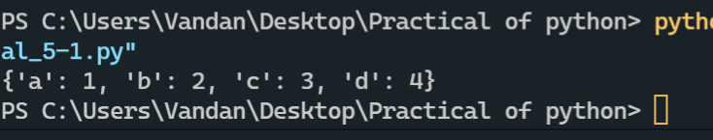

1. Using above created dictionary perform following operations

1)Write a code to print out the value of a, d, and c.

2) Calculate the sum of the value of a,b,c,d and print it.

3)Add a new key, value pair (e,5) to the dictionary and print dictionary.

**Code:**

d1  = {"a":1,"b":2,"c":3,"d":4}

print(d1["a"])

print(d1["b"])

print(d1["c"])

print(d1["d"])

**Output:**

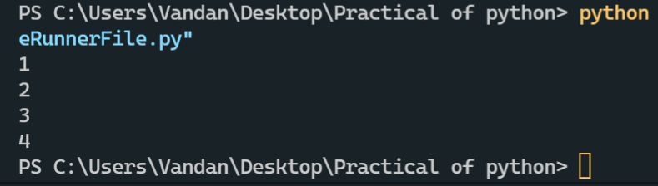

**Code:**

d2  = {"a":1,"b":2,"c":3,"d":4}

sum = 0

*for* i *in* d2:

    sum = sum + d2[i]

print("Sum=",sum)

**Output:**

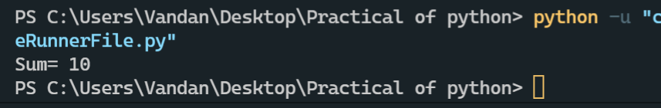

**Code:**

d1  = {"a":1,"b":2,"c":3,"d":4}

d1.update({'e':5})

print(d1)

d1.update([('e',6)])

print(d1)

**Output:**

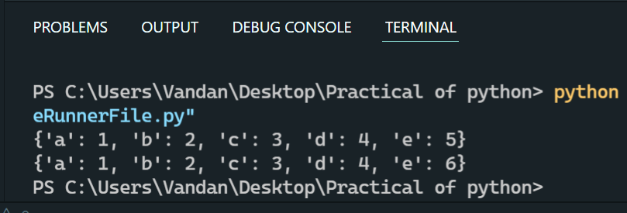

1. Filter the dictionary by removing all items with a value greater than 2.

d={“a”:1, “b”:2, “c”:3, “d”:4, “d”:5}

**Code:**

d1  = {"a":1,"b":2,"c":3,"d":4}

*for* i *in* list(d1.keys()):

*if* d1[i]>2:

       d1.pop(i)

print(d1)

**Output:**

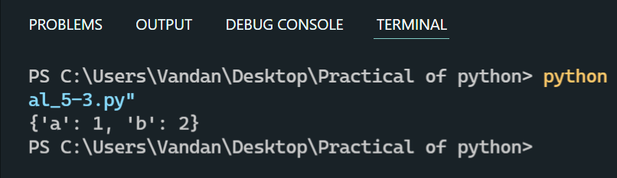

1. Print the names which contain the character 'a' from the dictionary containing 2 lists of male and female students given below.

{"male": ["Tom", "Charlie", "Harry", "Frank"],

"female":["Sarah", "Huda", "Samantha", "Emily", "Elizabeth"] }

**Code:**

d1={"male": ["Tom", "Charlie", "Harry", "Frank"],"female":["Sarah", "Huda",

"Samantha", "Emily", "Elizabeth"] }

*for* i *in* d1.values():

*for* j *in* i:

*if*('a' in j):

           print(j)

**Output:**

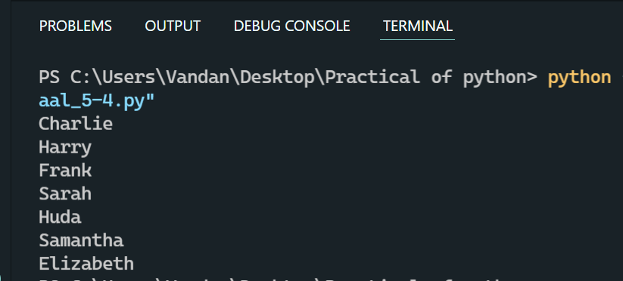

1. You have 4 films in the dictionary with the age and number of seats available as indicated below. Write a programme to ask for a film and check for the person that he is eligible to watch movie, also check ticket availability and movie availability in the cinema.

"War": [3,5],

"Bourne": [18,5],

"Gully boy": [15,5],

"Uri":[12, 5]

**Code:**

d1={"War": [3,5],"Bourne": [18,5],"Gully boy": [15,5],"Uri":[12, 5]}

movie =input("enter a movie name :")

*if* movie in d1.keys():

     print ("{} movie is available".format(movie))

     tkt=int(input("enter a number of tickets you want to buy : "))

*if*(d1[movie][1]>tkt):

        print("tickets are available")

        age=int(input("enter the age of youngest person in your group : "))

*if*(age>d1[movie][0]):

            print("you are successfully buy tickets")

*else*:

            print("youngest person is too small for watch movie")

*else*:

         print ("only {} tickets are availabel".formate(d1[movie][1]))

*else*:

   print("the movie is not avilabel")

d1[movie][1]-=tkt

print ("{} tickets are remaining".format(d1[movie][1]))

**Output:**

